Waymo Lane Change Data Sample (Example: scenario id 24)

**Attribute Of Car Follow Data**

You can find sample dataset here: LaneChangeData/SampleLaneChangeData.csv

**NewSID:** A unique number identifier for this scenario.

* Not the same number identifier as car follow data

**time:** Repeated field containing timestamps for each step in the Scenario starting at zero.

**longitudinal_dist_AV:** longitudinal distance of AV

**LateralPosition_AV:** lateral Position of AV

**localCoor_OrgLaneC:** local coordinate of original lane center

**localCoor_tgtLaneC:** local coordinate of target lane center

**localCoor_RoadLine:** local coordinate of road lane

**AV_x:** AV global coordinate x from map

**AV_y:** AV global coordinate y from map

**globalCoor_OrgLaneCx:** global coordinate x of original lane center

**globalCoor_OrgLaneCy:** global coordinate y of original lane center

**globalCoor_tgtLaneCx:** global coordinate x of target lane center

**globalCoor_tgtLaneCy:** global coordinate y of target lane center

**globalCoor_RoadLanex:** global coordinate x of road lane

**globalCoor_RoadLaney:** global coordinate y of road lane

**isGenLine:** Used to mark lines containing generated lines.

* 1 -> used generated line, otherwise 0

**isAvgLC:** Used to mark road line generated through averaging two lane centers.

* 1 -> yes, otherwise 0

**isGenPointBetw:** Used to mark points in between lane centers for the purpose of filling gaps.

* 1 -> used generated points between lane centers, otherwise 0

**Note: in the output, the scenario number id is different from original waymo data, and it only contains AV information.**

**Visualization Of Lane Change Data**

Top left graph: AV trajectory, original and target lane center and Road line in global coordinate from map.

Top right graph: longitudinal distance of AV

Bottom graph: AV trajectory, original and target lane center and Road line in local coordinate.

**Distance to reference point for Each vehicle in original and target lane center Graph**

**{Add here}**

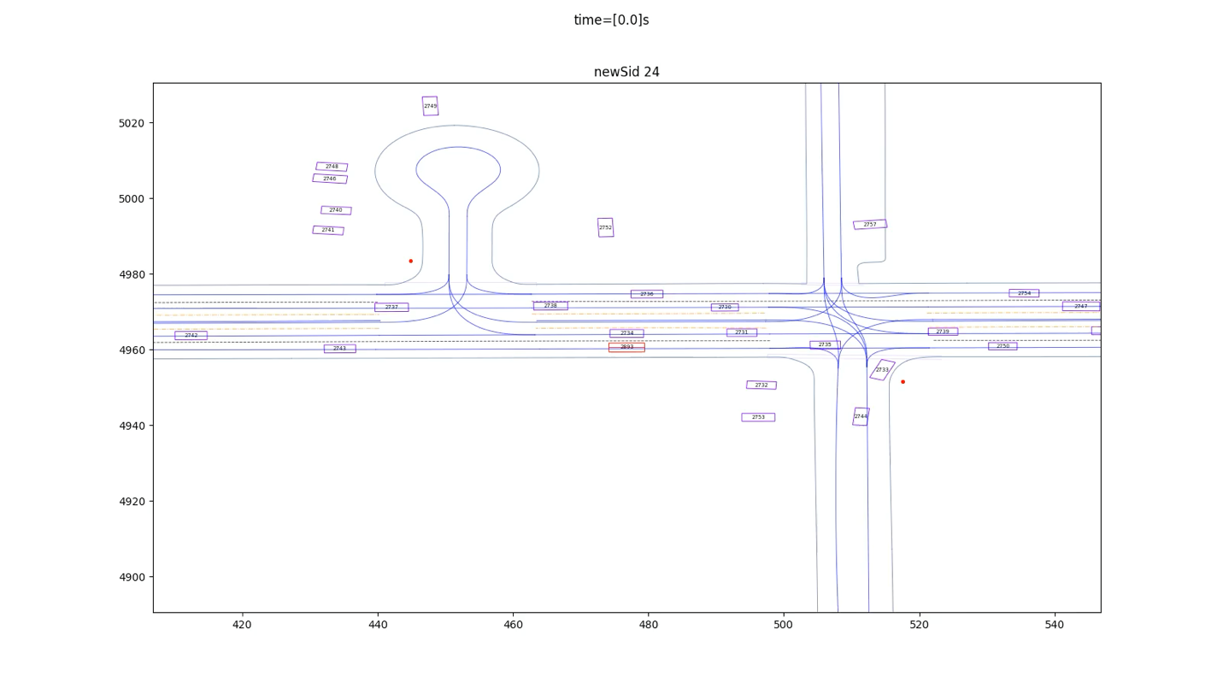**Animation for this scenario**

Animation for Lane change (newSid 24)

* Red box is AV